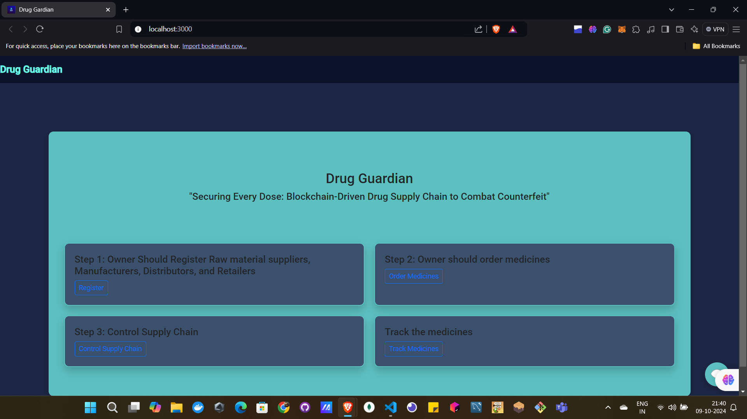

1st page of the website

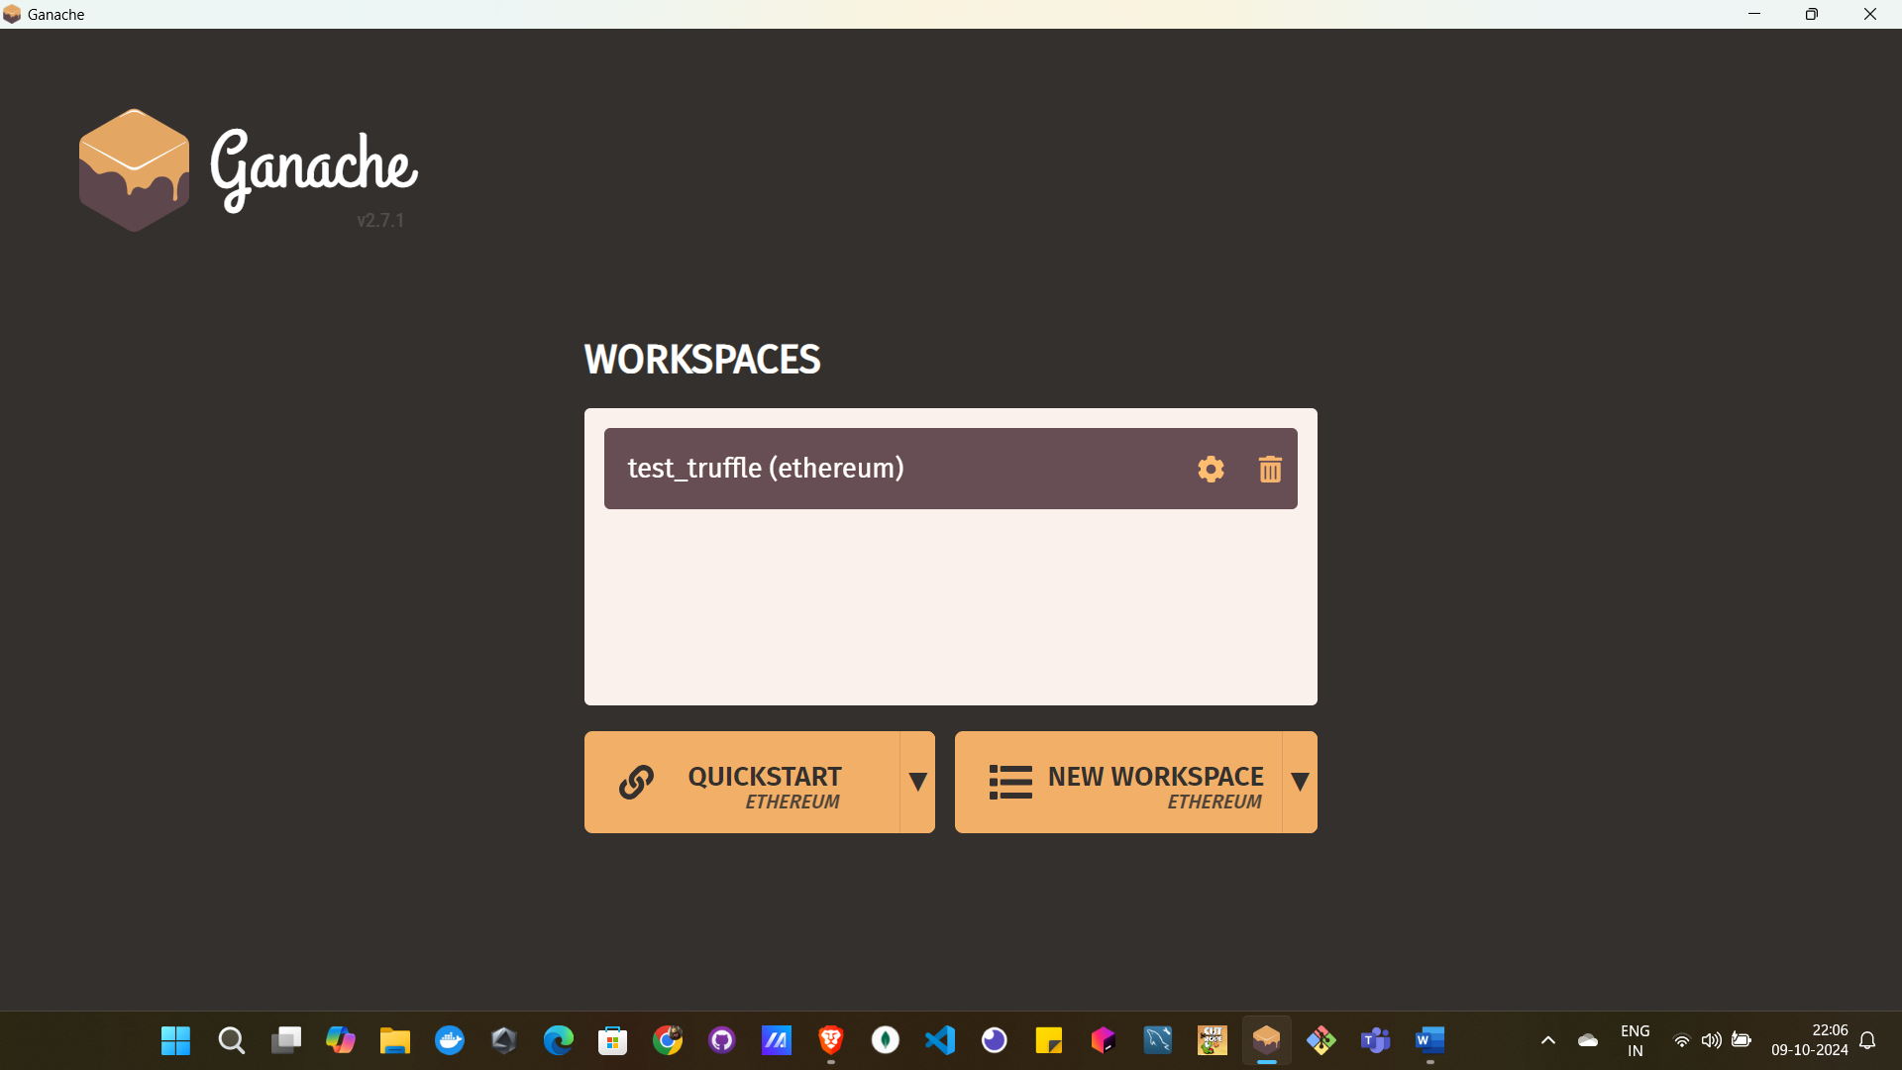

Then before register make connection between metamask and ganache blockchain by starting the workspaces created by you (here test_truffle is the workspace created by us)

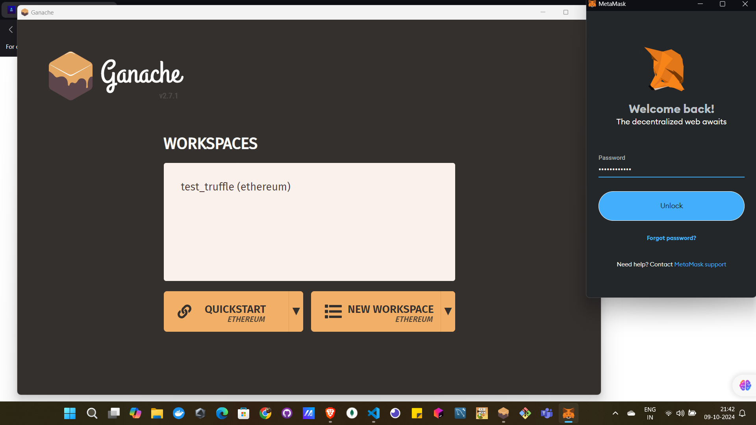  
enter the password of metamask and start the account .

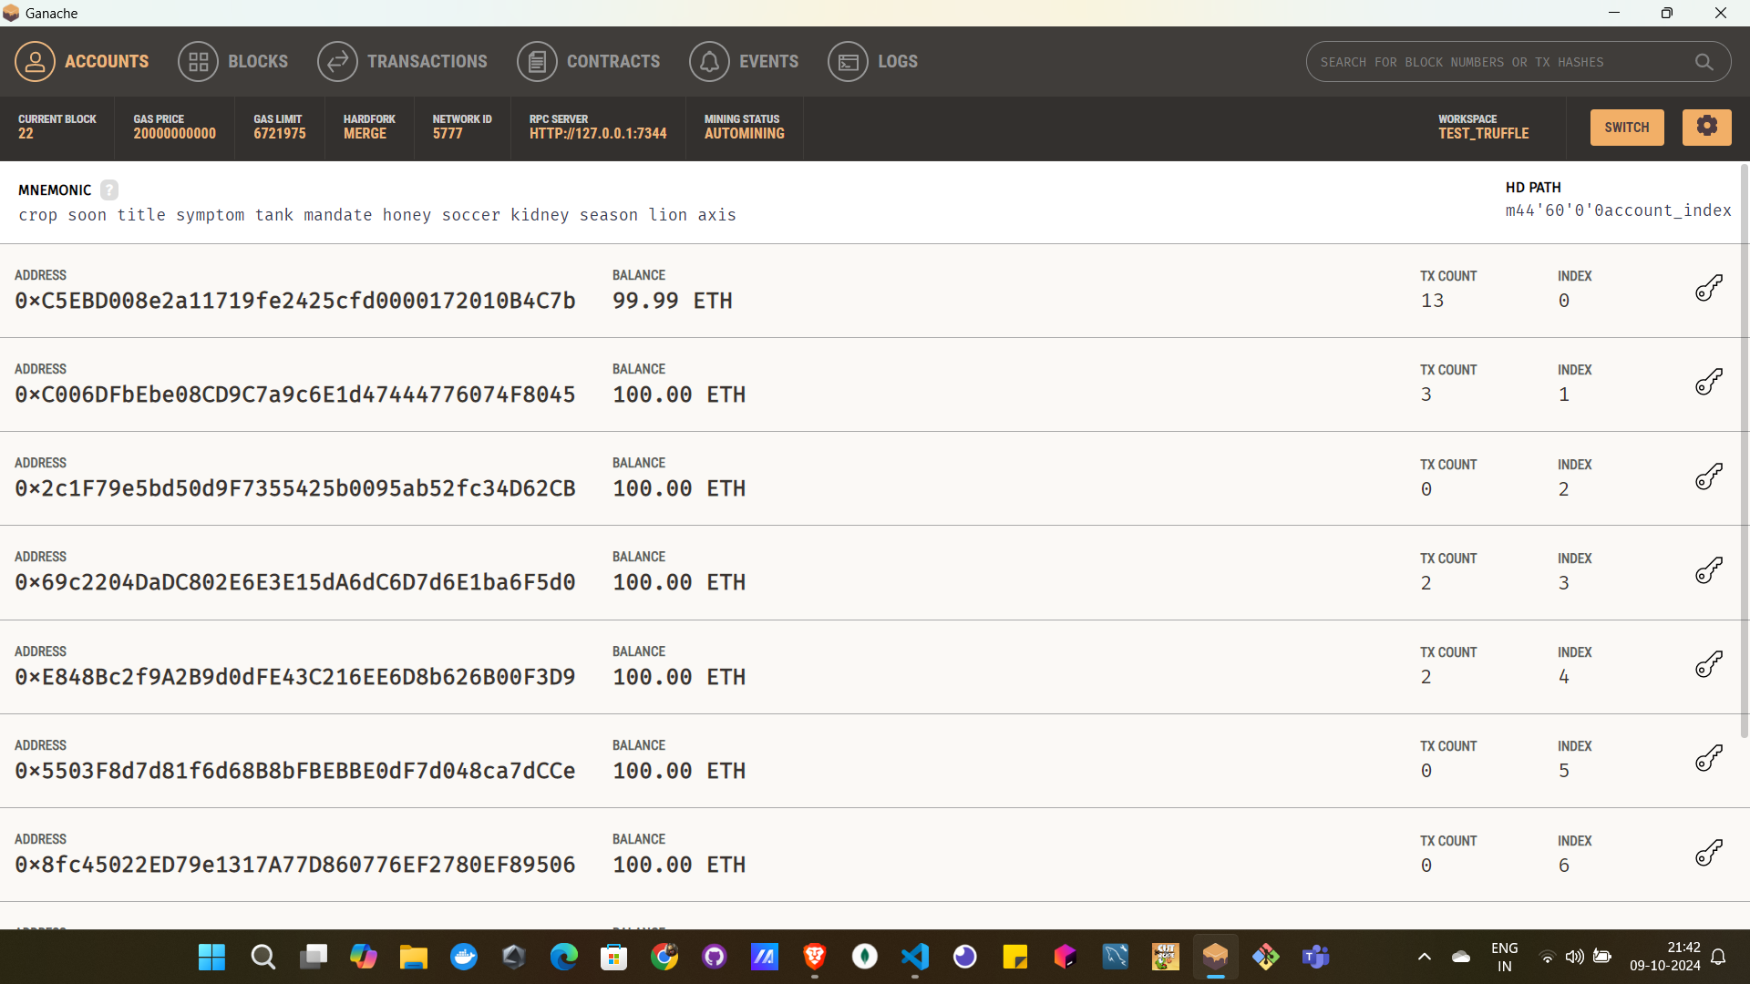

Once ganache started it will show the 10 ethereum accounts like this

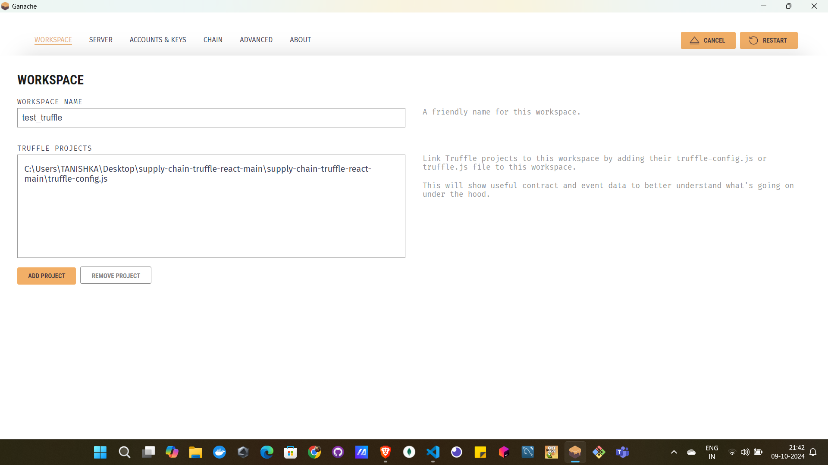

By clicking on settings you can go to this page where you can see the workspace and how the ganache is connected to truffle config.js file by giving the address for same .

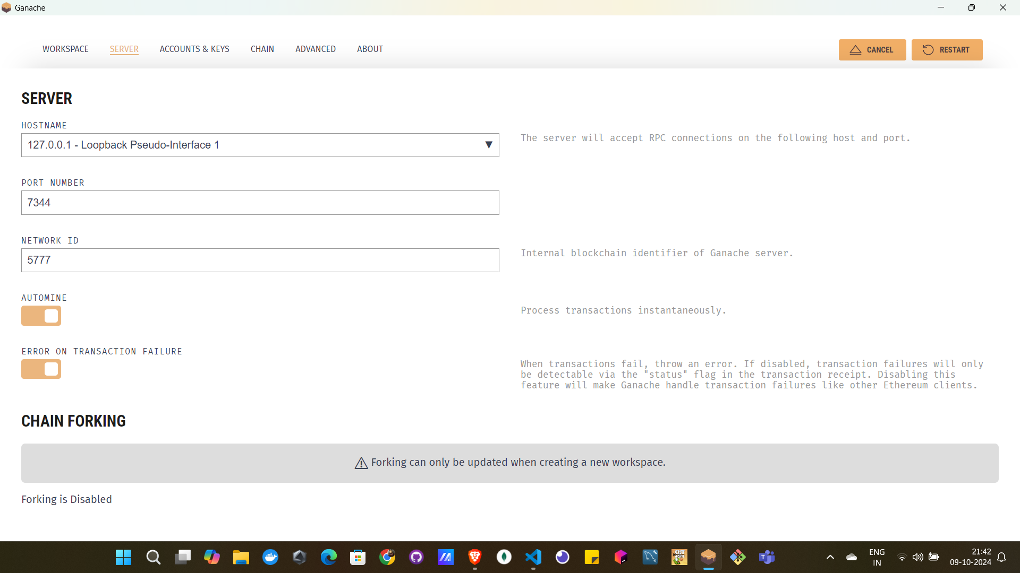

Here the server is connected to our host and port so the same server should be there in truffle config file too.th

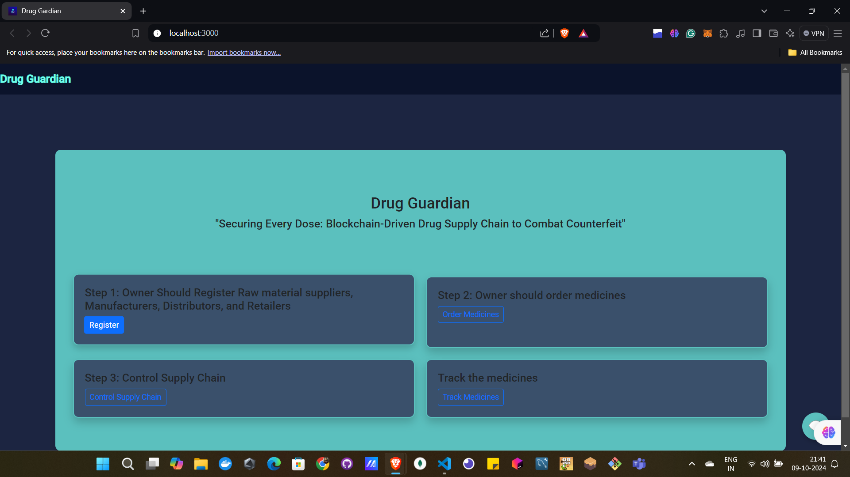

Step 1 : Click on register (here online owner can to this step)

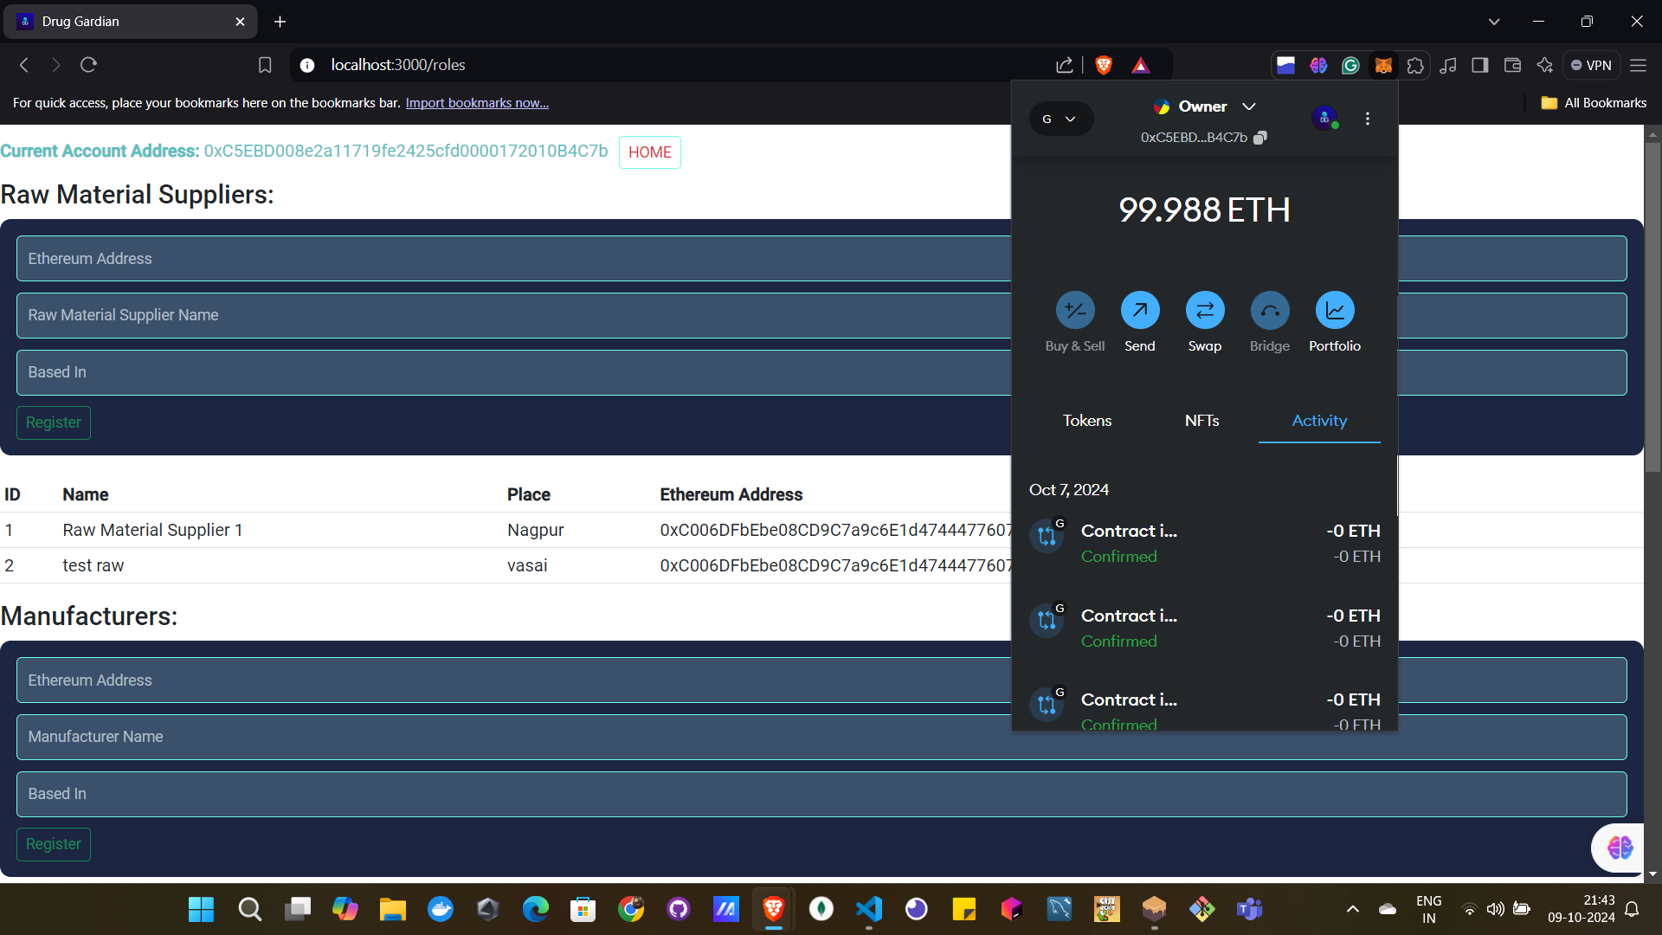

The current address is of owner as the owner will only perform the task of adding ddiffernt actors in metamask.

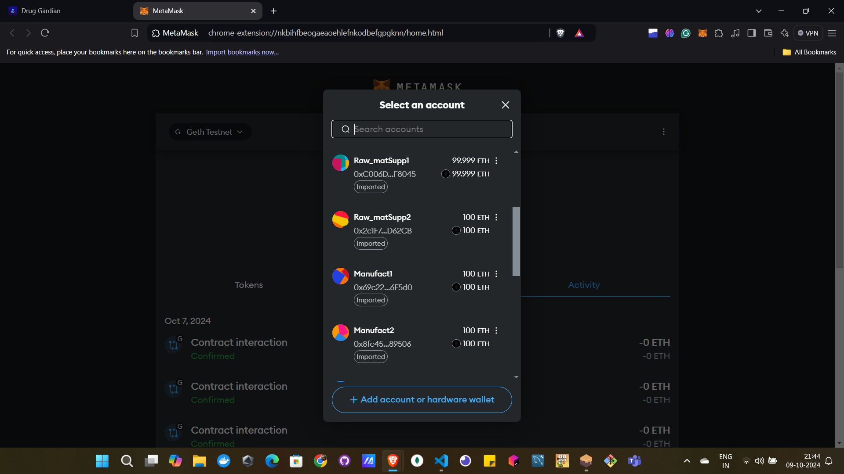

Here you can see the owner has added the actors (i.e. Raw material supplier, manufacturer, distributor and retailer) by importing the accounts from ganache blockchain (Geth test) by using the private key provided by it.

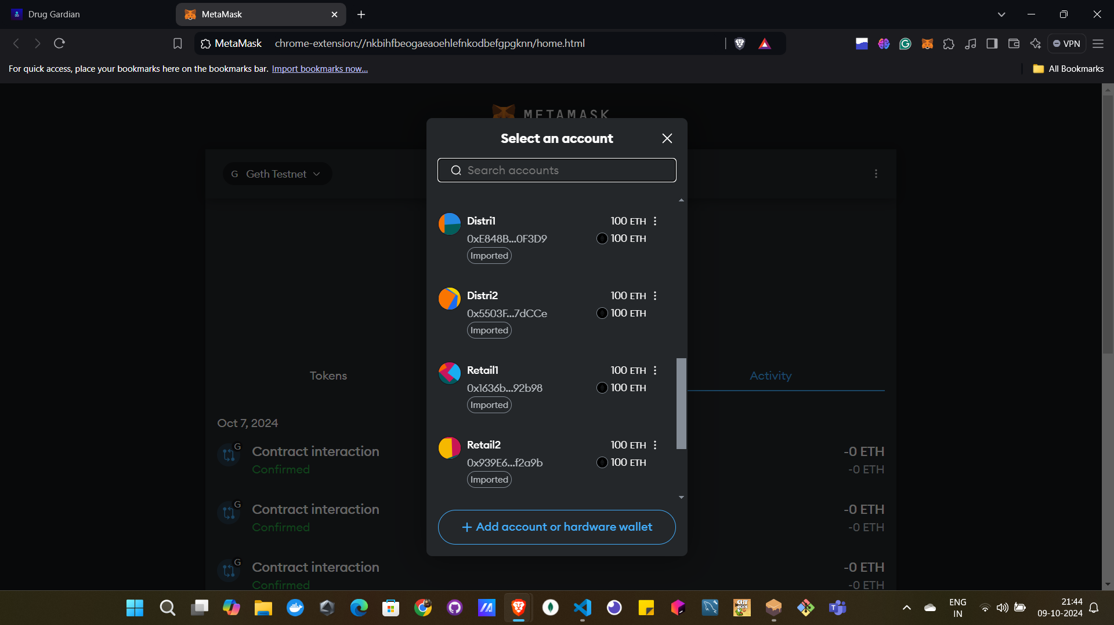

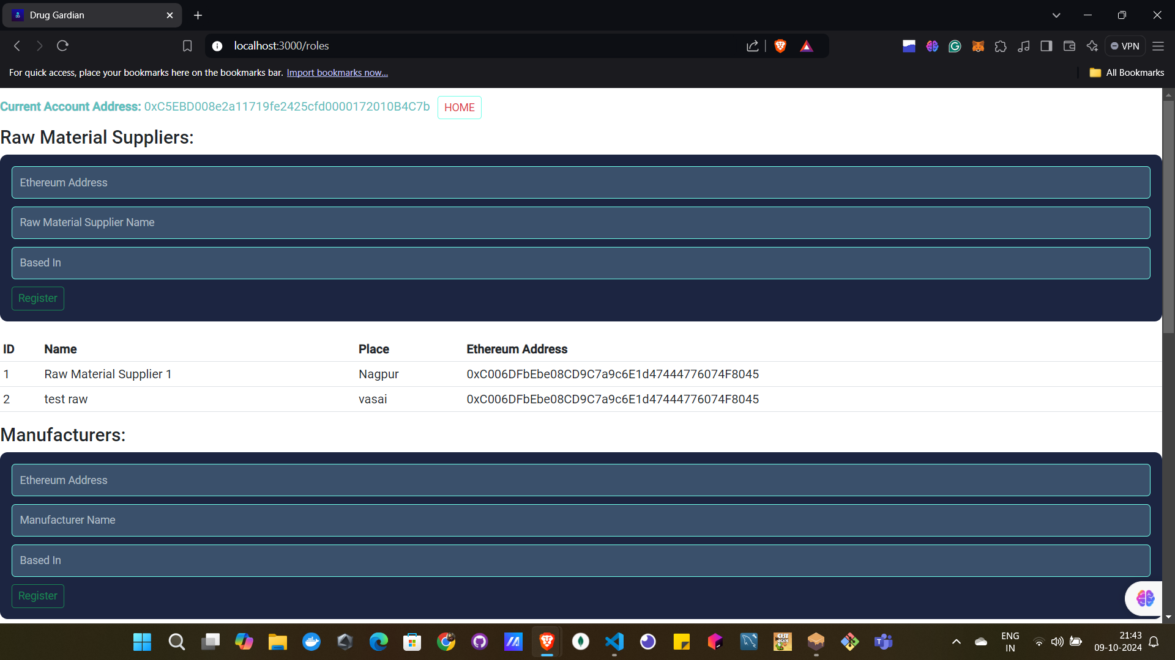

Once all required actors are made y owner there address are added one by one in then required filed and registered them with name , place and there ETH address .

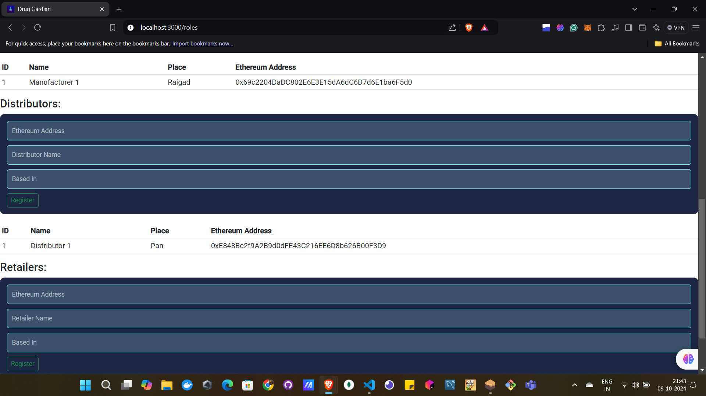

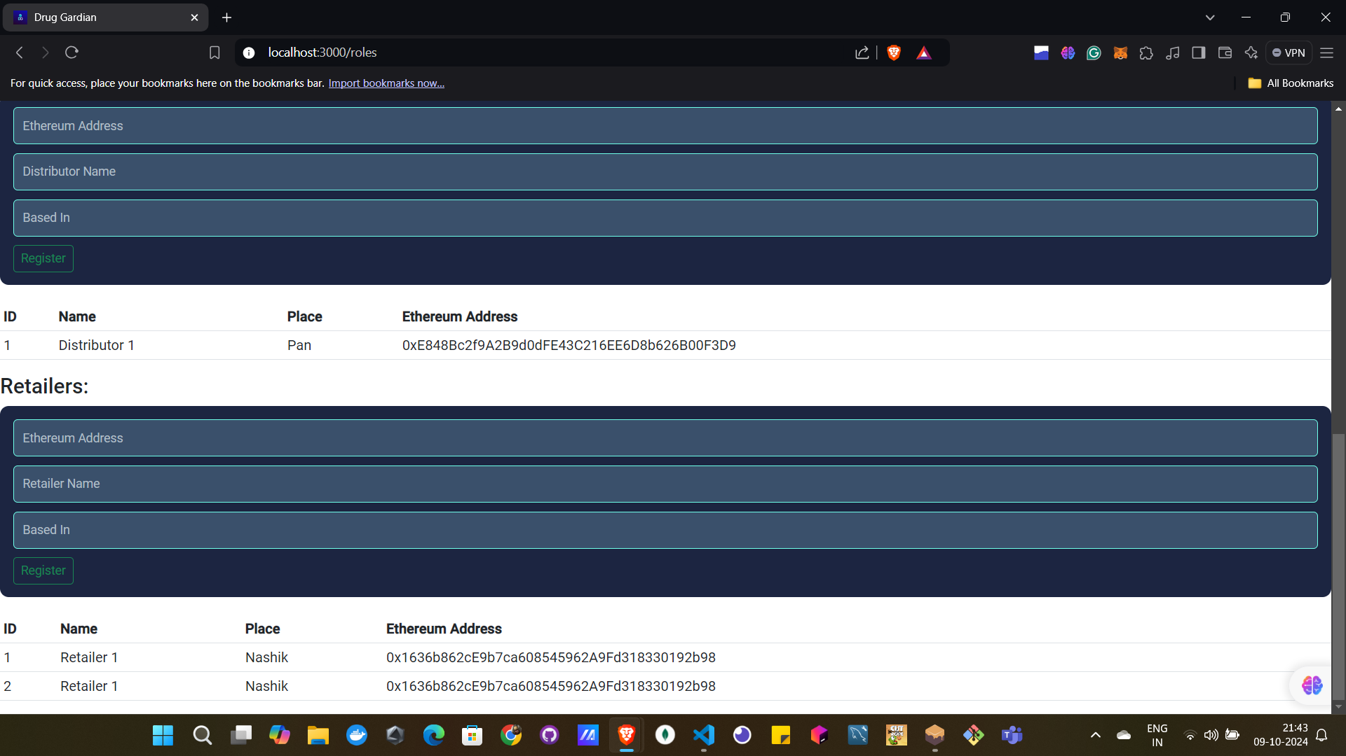

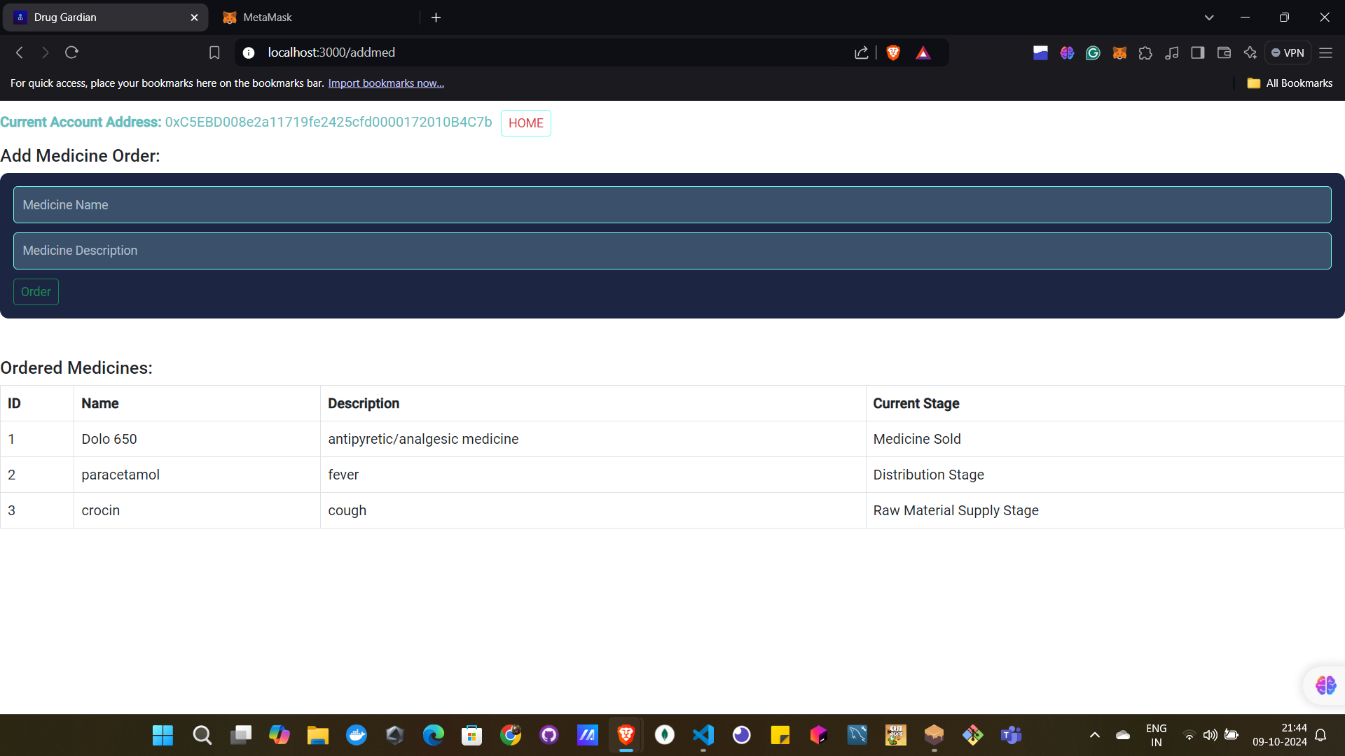

After registering all the actors successfully, now owner can move to add medicine which is required to be made.(This step is also performed only using owner’s account is anyone else try error will be occurred)

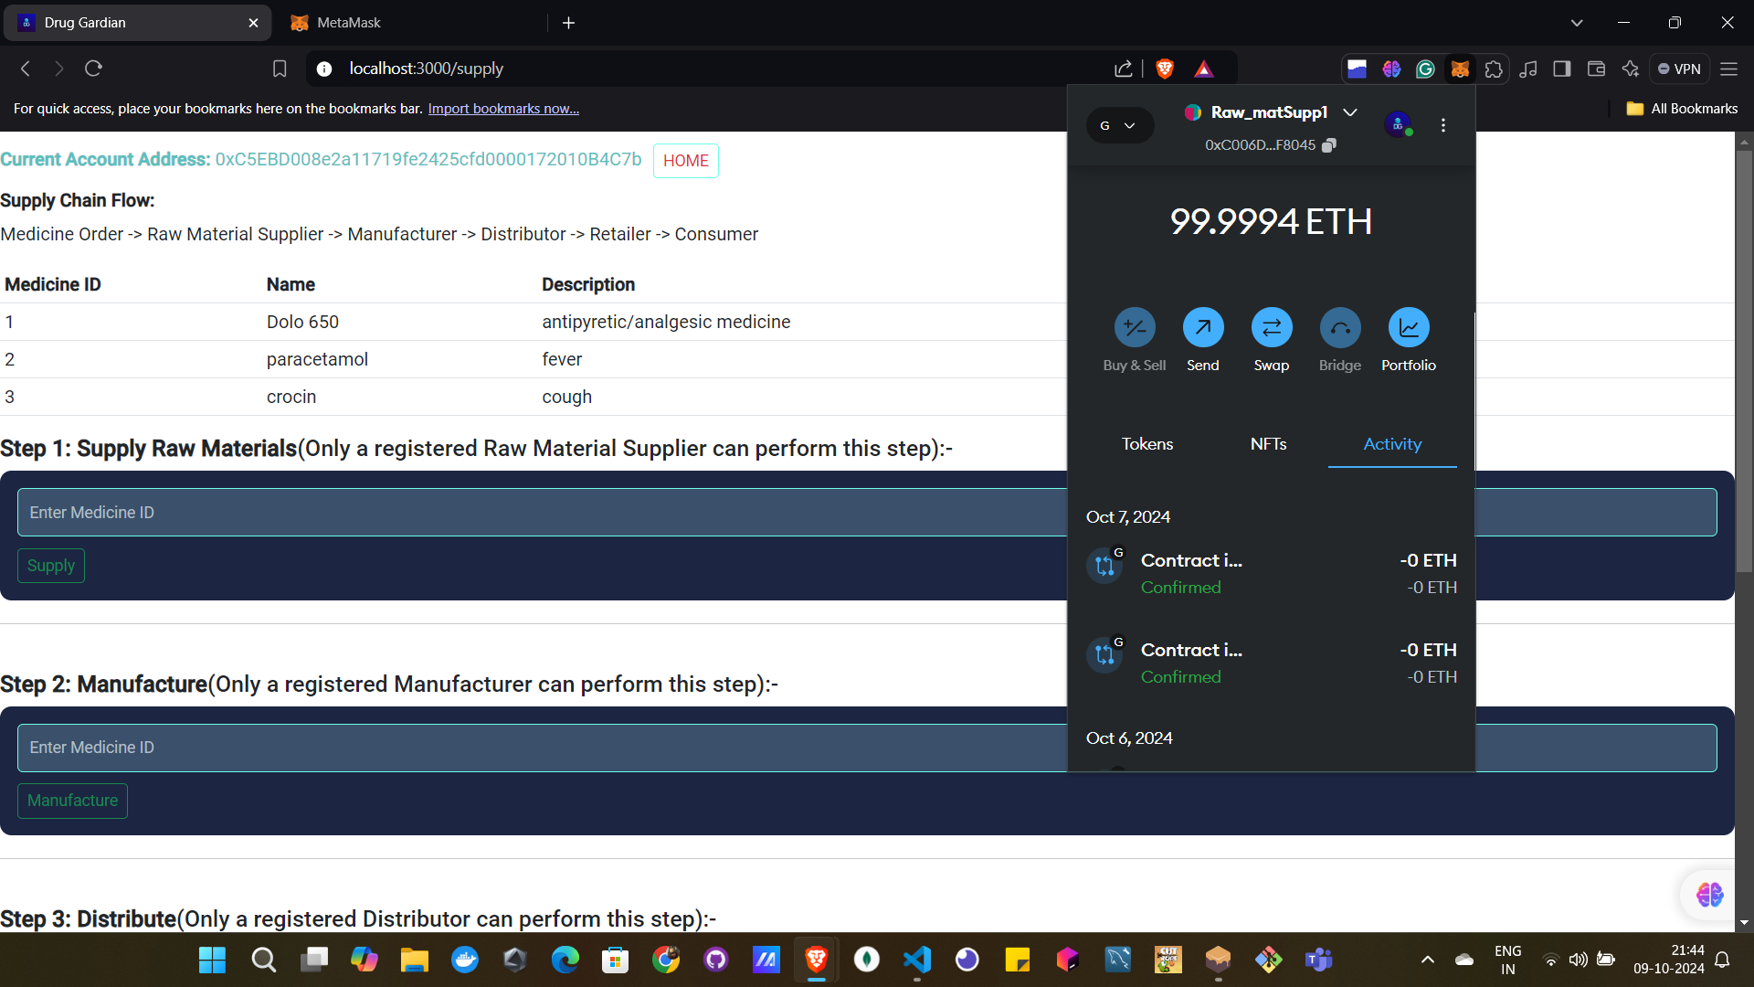

Once medicine is added then, each actor performs it work by using the accounts created for them. (e.g. “raw material supplier 1” will supply raw material by using its account and add the medicine id for which the supplier is supplying the material )

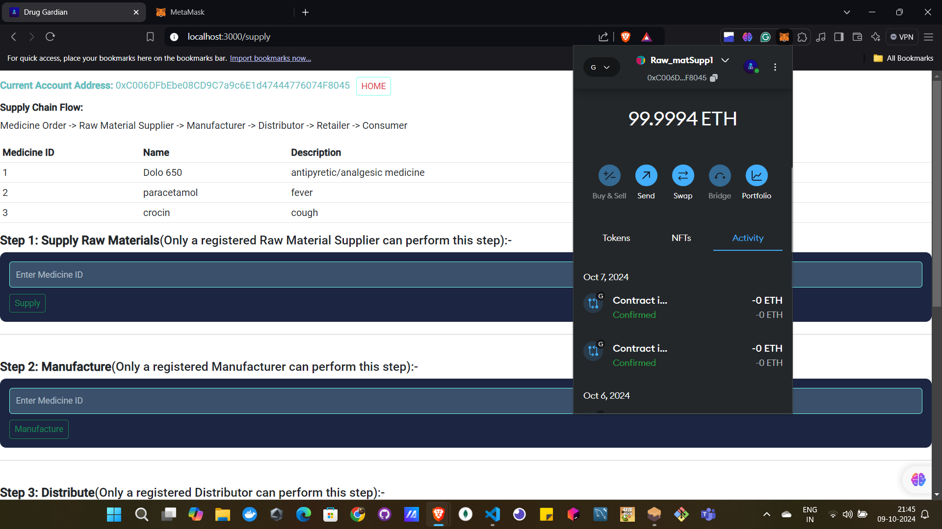

Similarly goes for other actors too.

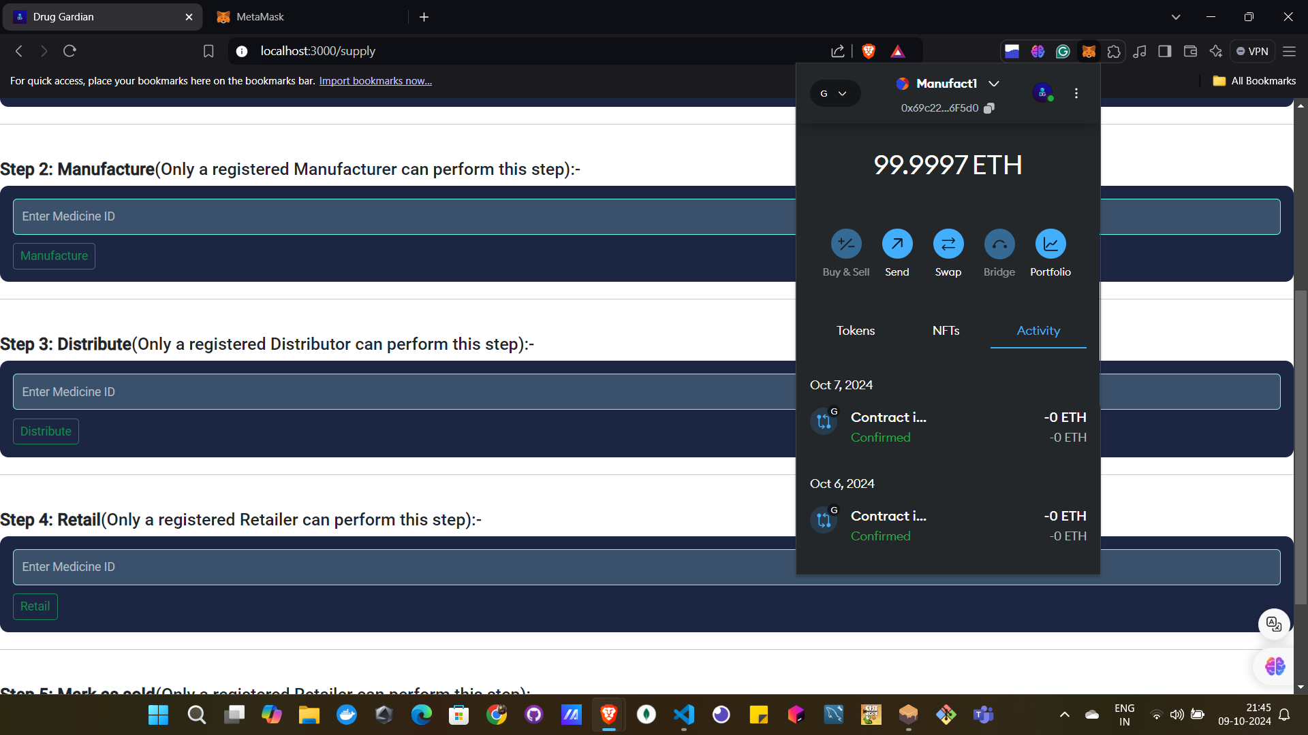

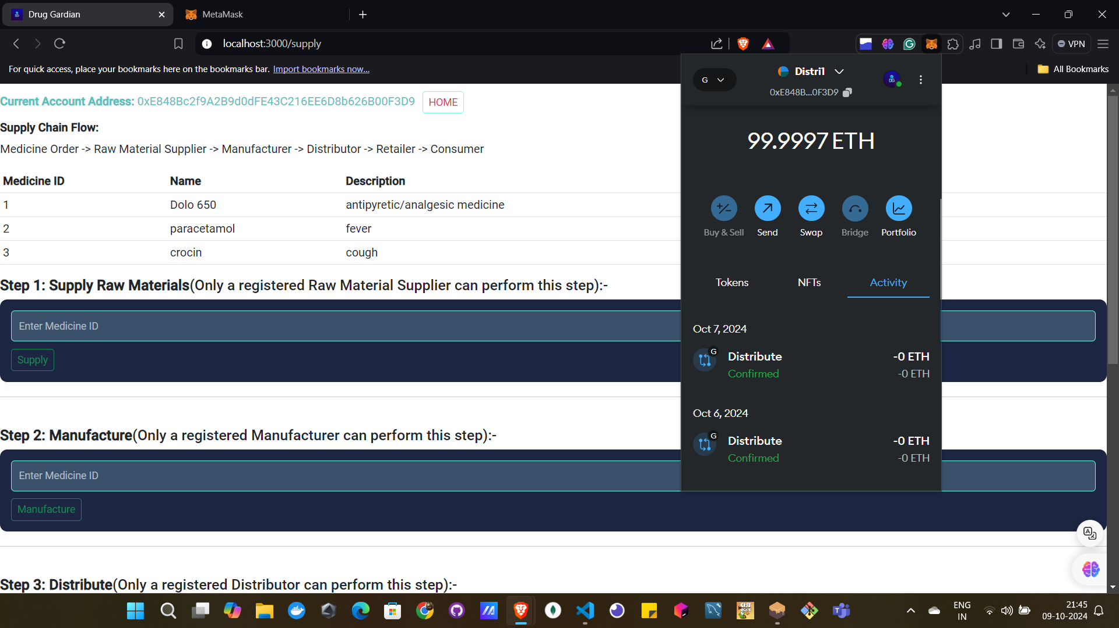

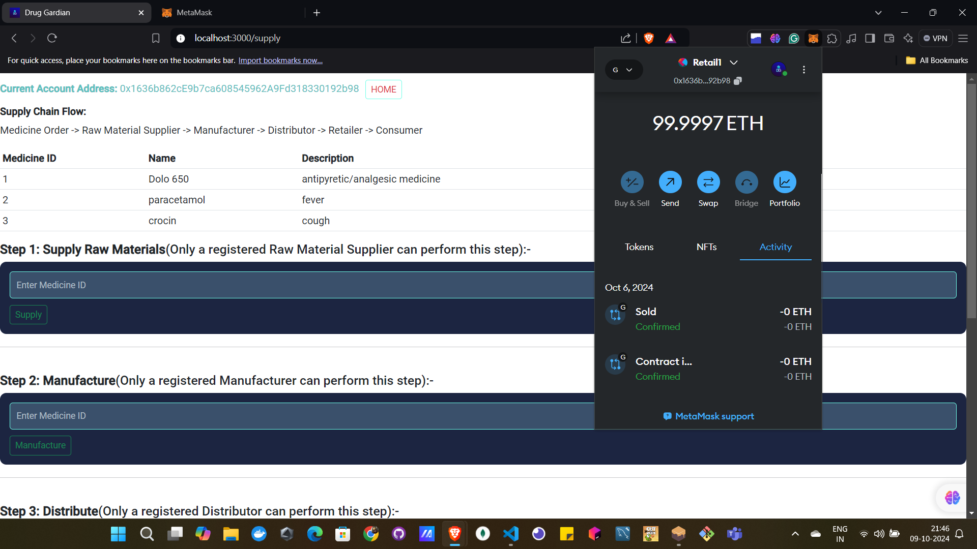

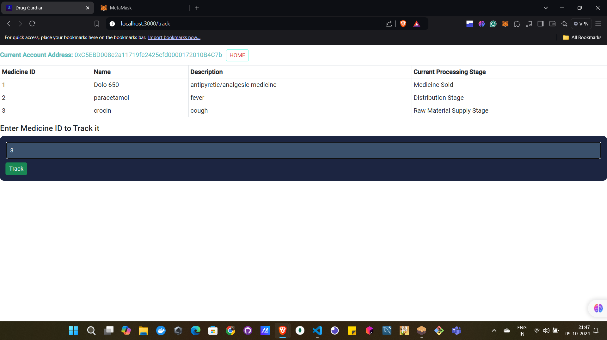

After performing above steps , you can track the medicine by entering the medicine id you want to track .

(Note :the tracking step can be performed by any actor as per there need )

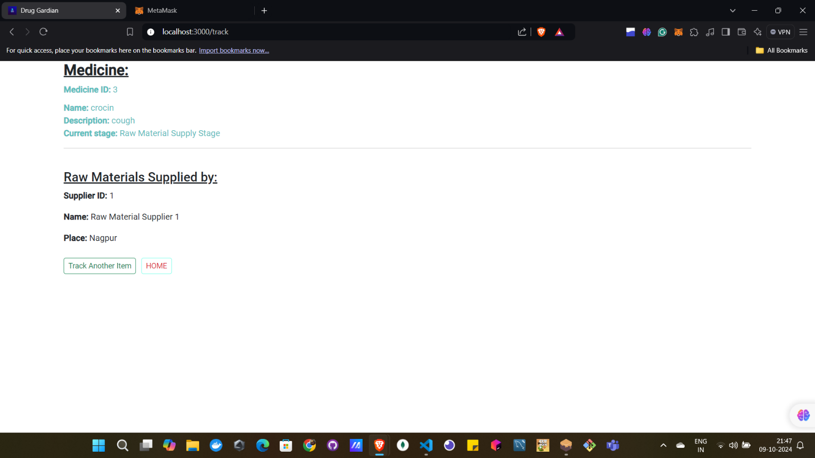

Finally you can see the status of your medicine in effective way.

